**Brand Promotion**

* Brand promotion is the way to inform, remind, persuade convincingly, and influence the consumers to drive their decision towards purchasing the product or service under a brand. Marketing force of a company conducts brand promotion primarily, though the wholesalers and retailers also can do it.



* Brand promotion employs a number of different tools and methods to market your brand, highlighting a company's personality, values and mission. It may not always involve direct promotion of the products or services offered but encourages customers to buy into the brand itself.
* Some essentials of brand promotion are-
* Google business posts
* Provide free samples
* Buy one get one free promotion

**TYPES OF BRAND PROMOTION-**

There are different ways to promote a brand or a company. They are-

* Advertising.
* Sales Promotion.
* Public Relations.

**Advertising-**

According to Oxford Languages, an advertisement is “a notice or announcement in a public medium promoting a product, service, or event.” But this isn’t the only advertising definition out there.



These definitions are relatively vague because it’s tricky to define ads in any great detail due to the variety of mediums they can come in. For example, an advertisement on a park bench is very different from a creative online advertising campaign on Facebook or Instagram.

**Sales Promotion-**

Some examples of commonly used sales promotion include giving out coupons or vouchers, temporarily reducing prices through discounts, sampling, offering giveaways, flash sales or buy-one-get-one-free offers, and lots more.

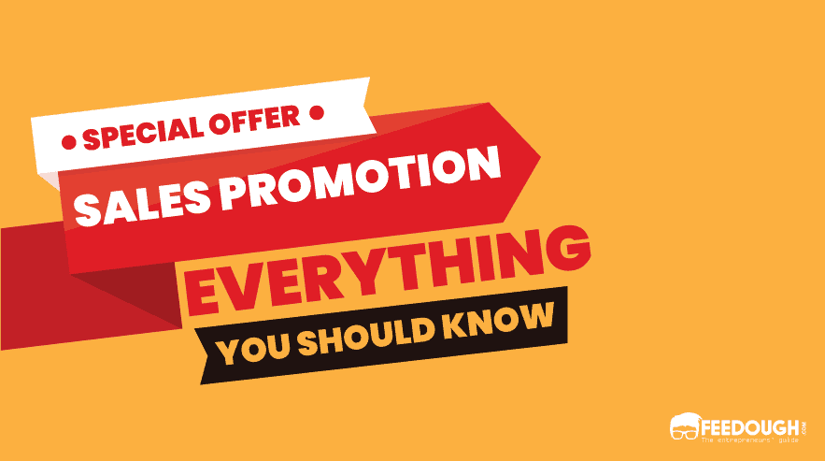

Some examples are-

* Providing free coupons
* Contests and giveaways
* Flash sale
* Free shipping

**Public relation-**

Public relations (PR), is the set of techniques and strategies related to managing how information about an individual or company is disseminated to the public, and especially the media.

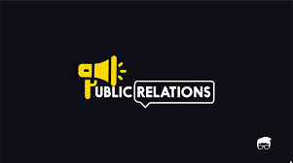

Public relations strategies make the brand capitalise on the opportunities. Google was in the news for donating to Ebola. Facebook promoted LGBTQ rights. Coca-Cola did a PR stunt against obesity. These opportunities even attract many influencers to share the brand story to their followers.